Cognitive

**Background** Mental processes were explored through introspection—analysis of one’s own conscious experience. Psychology’s empirical approach depends on observation, and private mental events proved difficult to observe. Furthermore, during the first half of the 20th century, the study of cognition was actively discouraged by the theoretical dominance of behaviorism.

**Cognitive psychology** is the branch of psychology that focuses on the study of higher mental processes, including thinking, language, memory, problem solving, knowing, reasoning, judging, and decision making.

focus on three major topics.

1. thinking and reasoning.
2. strategies for approaching problems, means of generating solutions, and ways of making judgments
3. how language is developed and acquired,

**Thinking and reasoning**

No other species contemplates, analyzes, recollects, or plans the way humans do.

Psychologists define **thinking** as brain activity in which we mentally manipulate information, including words, visual images, sounds, or other data.

elements involved in thinking

* **Mental** **images** are representations in the mind of an object or event. Research has found that our mental images have many of the properties of the actual stimuli they represent. Some experts see the production of mental images as a way to improve various skills. Mental imagery may improve other types of skills as well. For example, piano players who simply mentally rehearse an exercise show brain activity that is virtually identical to that of the people who actually practice the exercise manually.
* Using such categories reflects the operation of concepts. **Concepts** are mental groupings of similar objects, events, or people. Concepts help us classify newly encountered objects on the basis of our past experience. Prototypes are typical, highly representative examples of a concept that correspond to our mental image or best example of the concept. prototypes represent “best” or most common examples of a particular concept. For example, a Prius might be a prototype of the concept of “hybrid car.”

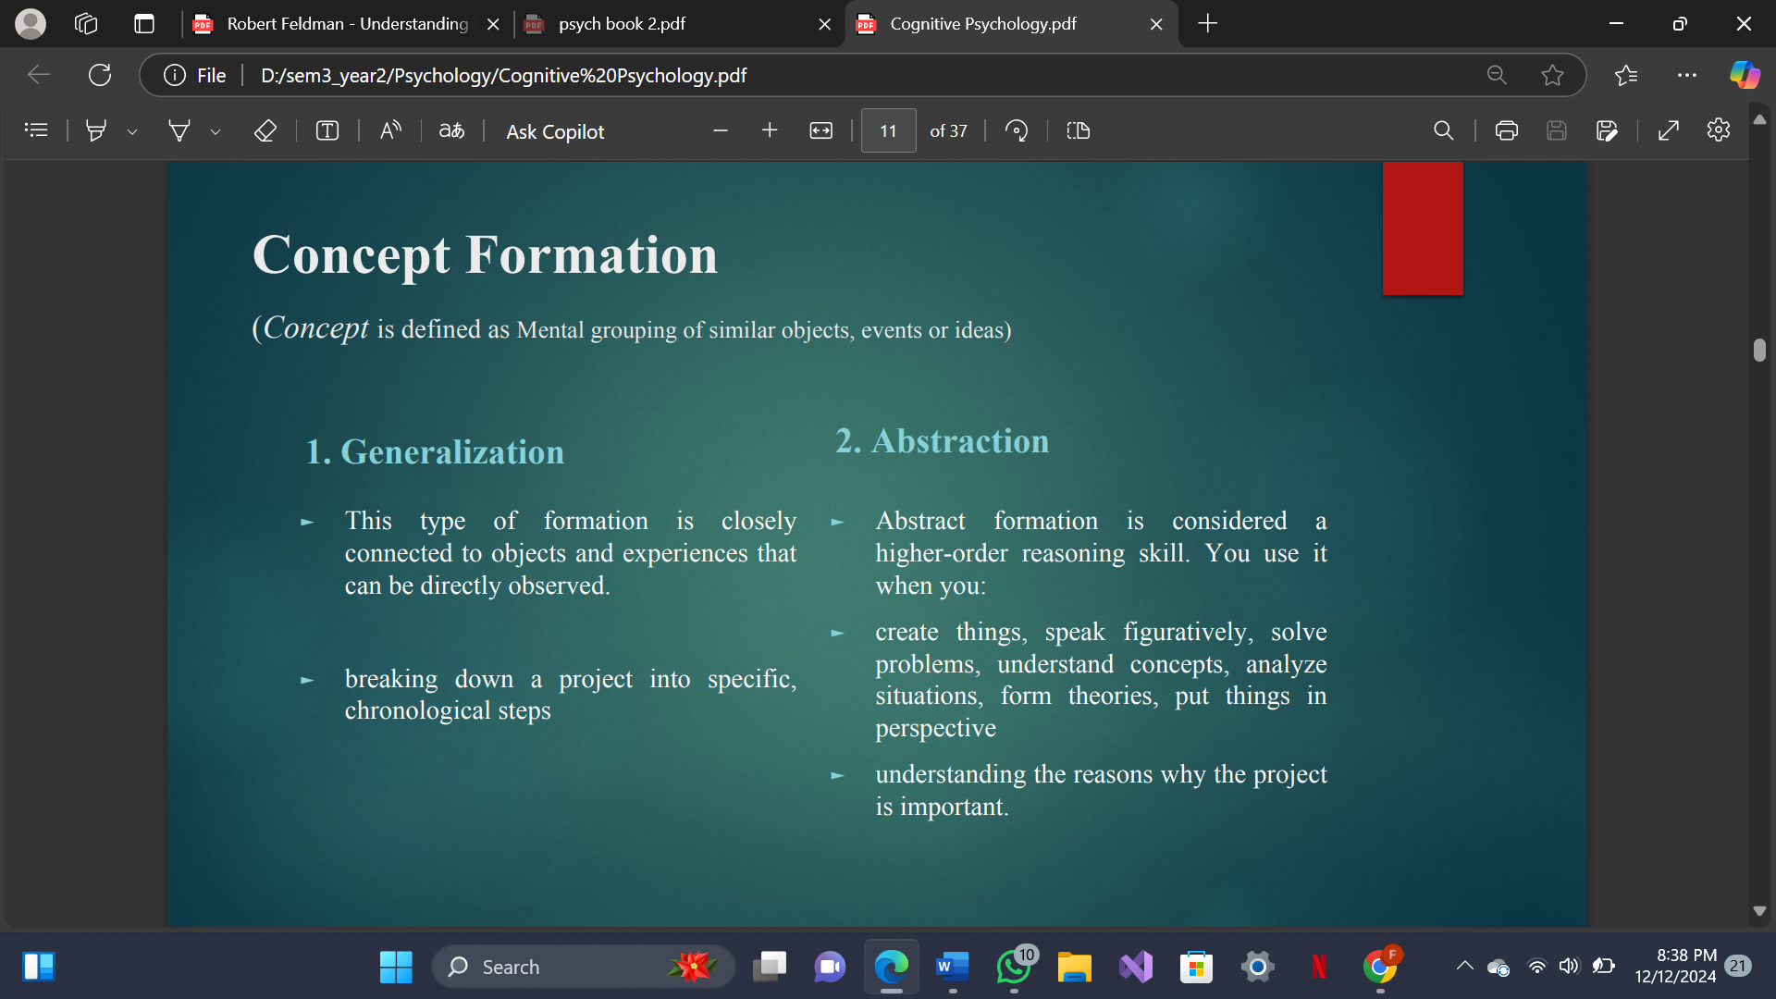

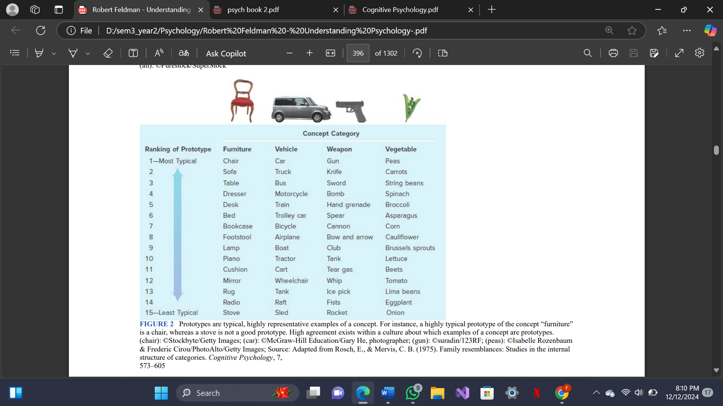

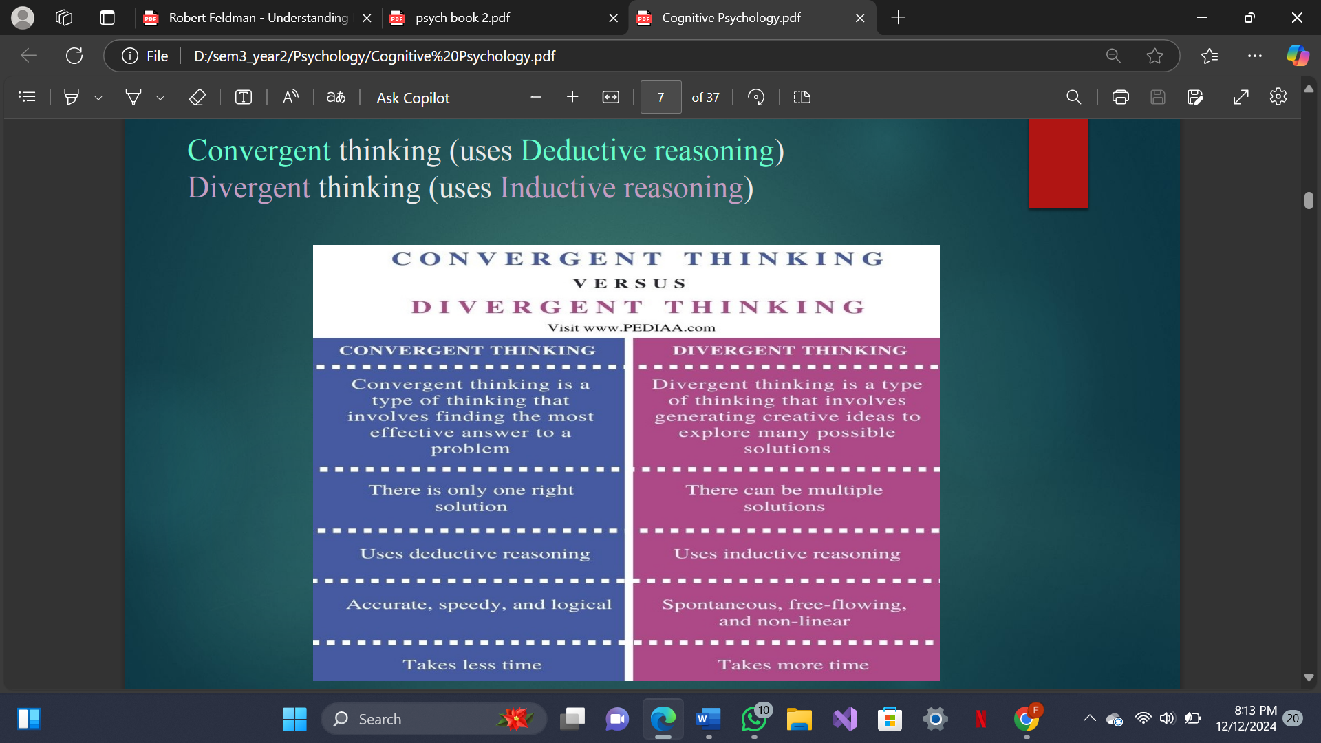

**reasoning**, the process by which information is used to draw conclusions and make decisions.

1. **Deductive reasoning** is reasoning from the general to the specific. Psychologists, like all scientists, use deductive reasoning when they start with a general, broad theory, then derive a hypothesis from the theory, and ultimately test the hypothesis by collecting data to arrive at a conclusion.
2. **Inductive reasoning** is reasoning from the specific to the general. Inductive reasoning is data driven, in that we accumulate pieces of information and put them together to form a conclusion. That’s what psychologists do when they study a sample of participants and then they use the information they observe to form a conclusion about the broader population from which the sample is drawn.

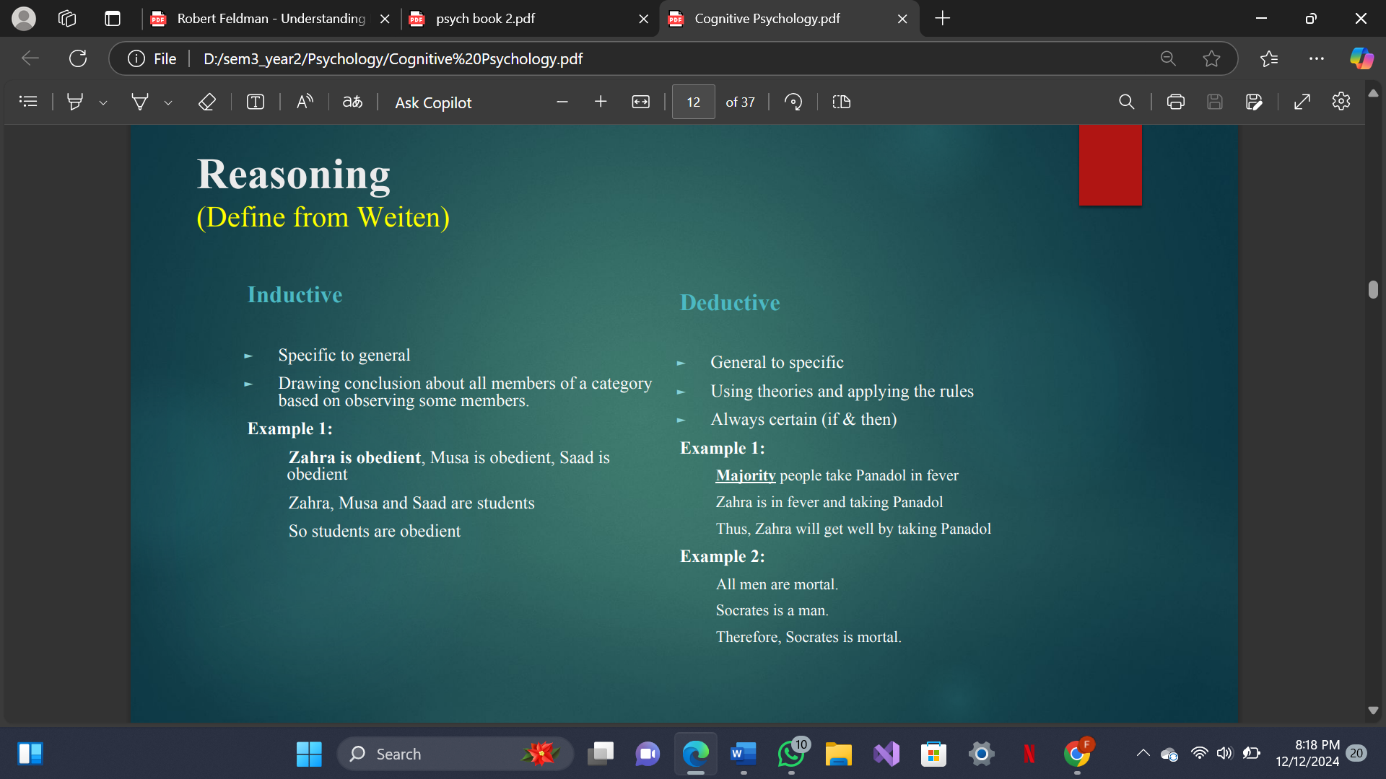

**Problem Solving**

**It refers to active efforts to discover what must be done to acypes by Jim Greeno (1978) hieve a goal that is not readily attainable.**

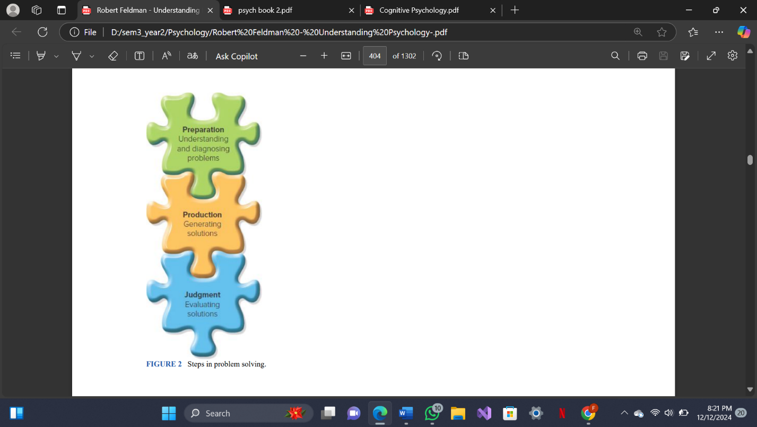

In a **well-defined problem**—such as a mathematical equation or the solution to a jigsaw puzzle—both the nature of the problem itself and the information needed to solve it are available and clear.

With an **ill-defined problem**, not only may the specific nature of the problem be unclear, the information required to solve the problem may be even less obvious

► Types by Jim Greeno (1978)

arrangement, inducing structure, and transformation.

* Arrangement problems require the problem solver to rearrange or recombine elements of the problem in a way that will satisfy specific criteria. Usually, several different arrangements can be made, but only one or a few of the arrangements will produce a solution. Anagram problems and jigsaw puzzles are examples of arrangement problems
* In problems of inducing structure, a person must identify the existing relationships among the elements presented in the problem and then construct a new relationship among them. In such a problem, the problem solver must determine not only the relationships among the elements but also the structure and size of the elements involved.
* —transformation problems—that consist of an initial state, a goal state, and a method for changing the initial state into the goal state. In the Tower of Hanoi problem

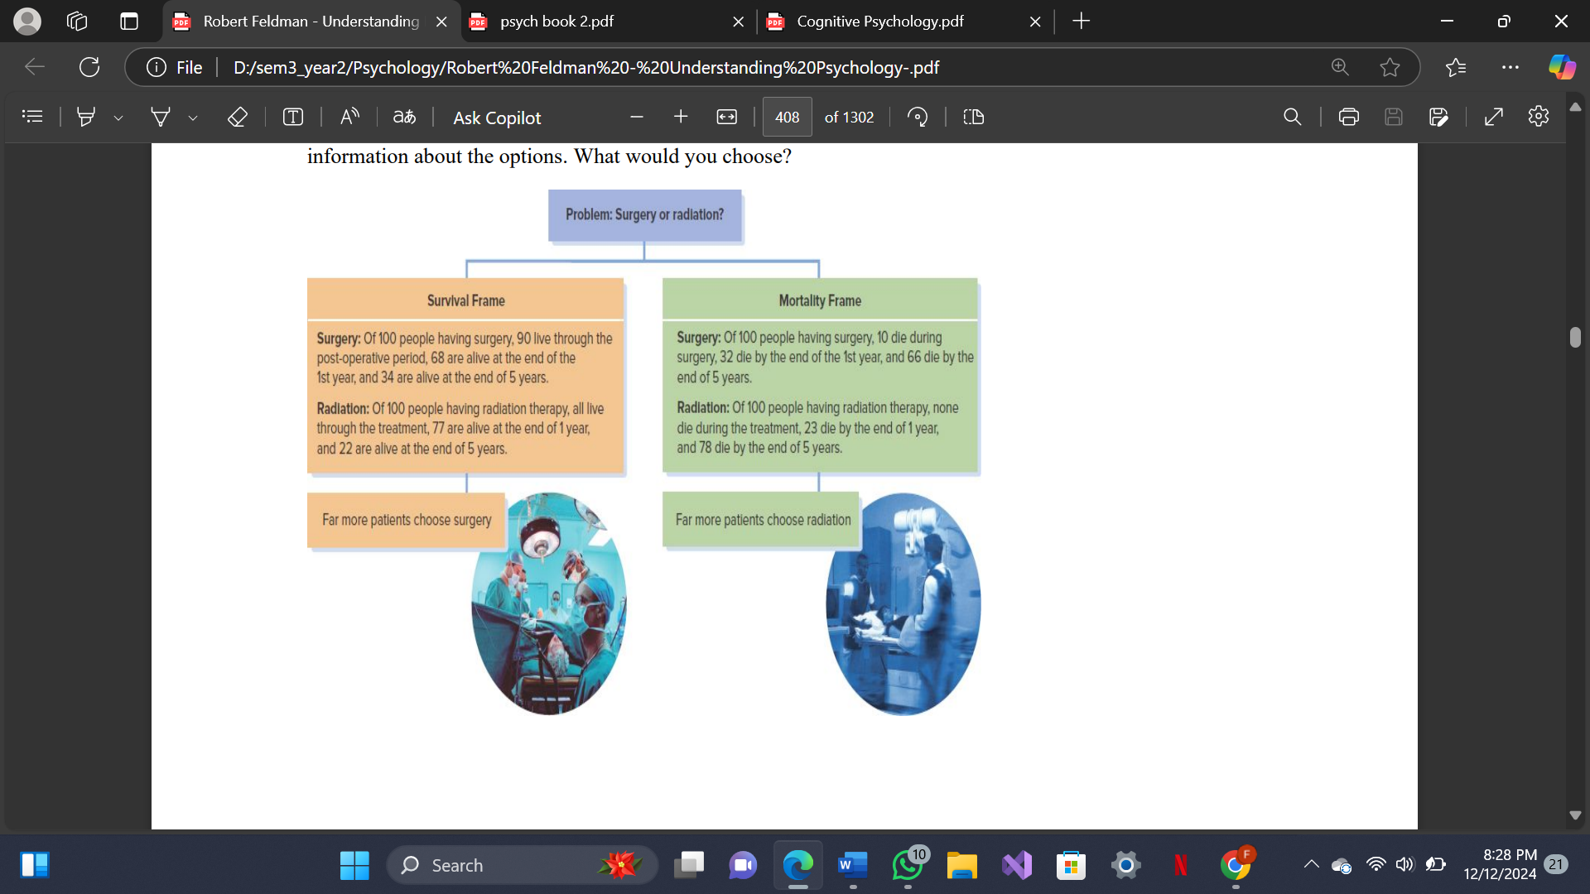

Methods used in problem solving

An **algorithm** is a rule that, if applied appropriately, guarantees a solution to a problem. We can use an algorithm even if we cannot understand why it works.

A **heuristic** is a thinking strategy that may lead us to a solution to a problem or decision but—unlike algorithms—may sometimes lead to errors. Heuristics increase the likelihood of success in coming to a solution, but, unlike algorithms, they cannot ensure it.

Barriers to effective Problem Solving

1) **Irrelevant Information** Sternberg (1986) points out that people often incorrectly assume that all the numerical information in a problem is necessary to solve it. They therefore try to figure out how to use quantitative information before they even consider whether it’s relevant. Focusing on irrelevant information can have adverse effects on reasoning and problem solving (Gaeth & Shanteau, 2000)

2**) Functional fixedness** Another common barrier to successful problem solving, identified by Gestalt psychologists, is functional fixedness—the tendency to perceive an item only in terms of its most common use

3) **Mental set** A mental set exists when people persist in using problem-solving strategies that have worked in the past.

4) **Unnecessary Constraints** Effective problem solving requires specifying all the constraints governing a problem without assuming any constraints that don’t exist

5) **confirmation bias** in which problem solvers prefer their first hypothesis and ignore contradictory information that supports alternative hypotheses or solutions.

**creativity**, the ability to generate original ideas or solve problems in novel ways

‘Creative thinking is defined as the thinking that enables students to apply their imagination to generating ideas, questions and hypotheses, experimenting with alternatives and to evaluating their own and their peers’ ideas, final products and processes (Kampylis and Berki)

Process of Creative Thinking

**Wallas’ Stages Model** ►

In 1926 Wallas proposed that creativity involved a person detecting new information (Preparation/Information phase), thinking about it (Incubation), generating a novel interpretation (Illumination) and then testing it (Verification).

**Preparation**: The mind prepares for the creative solution, which requires study and thinking intently on the subject—whether it be a musical composition, a new invention, a mathematical formula, or a business dilemma.

**Incubation**: The person steps away from the problem and takes up some form of activity like daydreaming, walking.

**Illumination**: Often as a flash, a brilliant idea shoots across the mind, frequently during a mundane task or while one is involved with something else.

**Verification**: The idea is tested to determine its validity. The composition is scored; the mathematical formula, proven

Characteristics/ Traits of a creative person

► Autonomous

► Introverted

► Open to new experiences

► Norm-doubting

► Self-confident

► Self-accepting

► Driven

► Ambitious

► Dominant

► Hostile

► Impulsive

**Language**

1. **Language** A language consists of symbols that convey meaning, plus rules for combining those symbols, that can be used to generate an infinite variety of messages.

2. **Phonology** Branch of linguistics that studies phonemes; basic speech sounds

3. **Morphology**

i. Branch of linguistics that studies word formation, word structure (as derivation, compounding)

ii. It is the study of how parts of words, called morphemes, create different meanings by combining with each other or standing alone

iii. Morphemes are the smallest units of meaning in a language

4. **Syntax** It’s the study of grammar, the rules that govern how words are built into allow for the formation of relations between sentences, words, and phrases. 5. Semantics Meaning in language

**Syntax** is a system of rules that specify how words can be arranged into sentences. A simple rule of syntax is that a sentence must have both a noun phrase and a verb phrase. Thus, “The sound of cars is annoying” is a sentence. However, “The sound of cars” is not a sentence, because it lacks a verb phrase.

**Semantics** is the area of language concerned with understanding the meaning of words and word combinations. Learning about semantics entails learning about the infinite variety of objects and actions that words refer to. A word’s meaning may consist of both its denotation, which is its dictionary definition, and its connotation, which includes its emotional overtones and secondary implications

**Intelligence**

**intelligence** is the capacity to understand the world, think rationally, and use resources effectively when faced with challenges. (Wechsler, 1944)

**Intelligence** is not a single, unitary ability, but rather a composite of several functions. (Anastasi, 1992)

An **intelligence** is the ability to solve problems or to create products that are valued within one or more cultural settings. (Gardner, 1993) Gardner has developed a theory of multiple intelligences that has become quite influential

An **intelligence** is performing an operation on a specific type of content to produce a particular product. (Guilford, 1967)

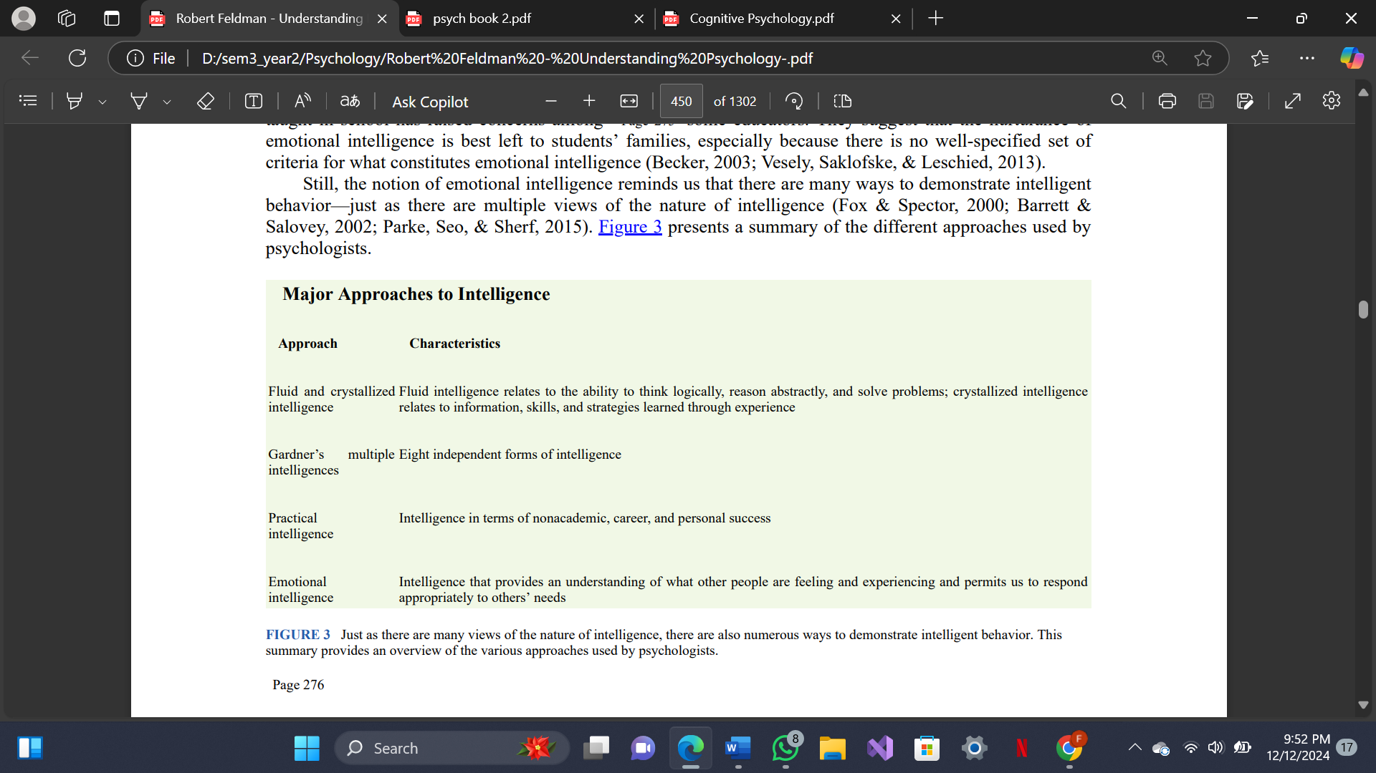

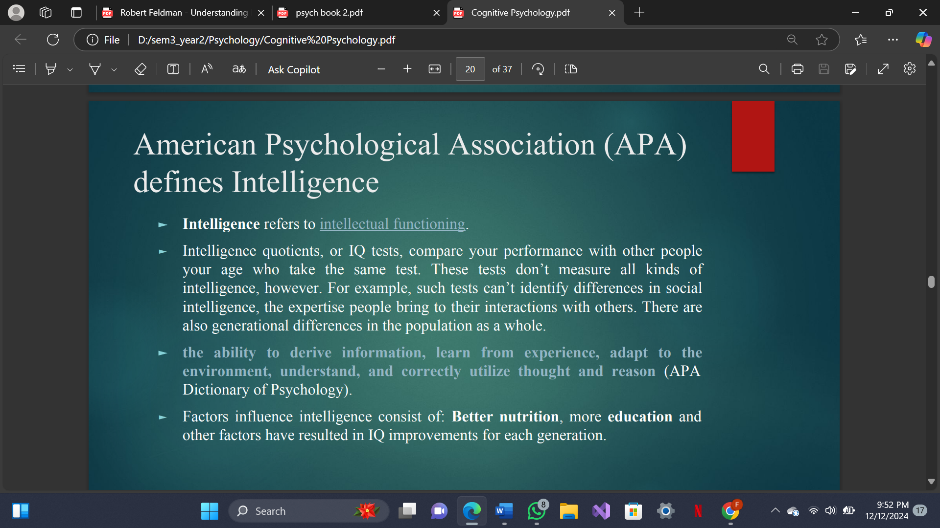

BINET AND THE DEVELOPMENT OF IQ TESTS

Alfred Binet (1857-1911) set out to develop a series of tasks designed to measure individual differences on the request of the French government due to the need for a reliable diagnostic system to identify children with mental retardation. The test was used and varied among children from the ages of 3 years to 12 years.

The differences that he intended to delineate included a number of complex mental facilities, such as memory, imagery, imagination, attention, comprehension, aesthetic sentiment, moral sentiment, muscular strength, motor ability, and hand-eye coordination.

The intelligence quotient (IQ) is a measure of intelligence that takes into account an individual’s mental and chronological (physical) age. the following formula in which MA stands for mental age and CA for chronological age:

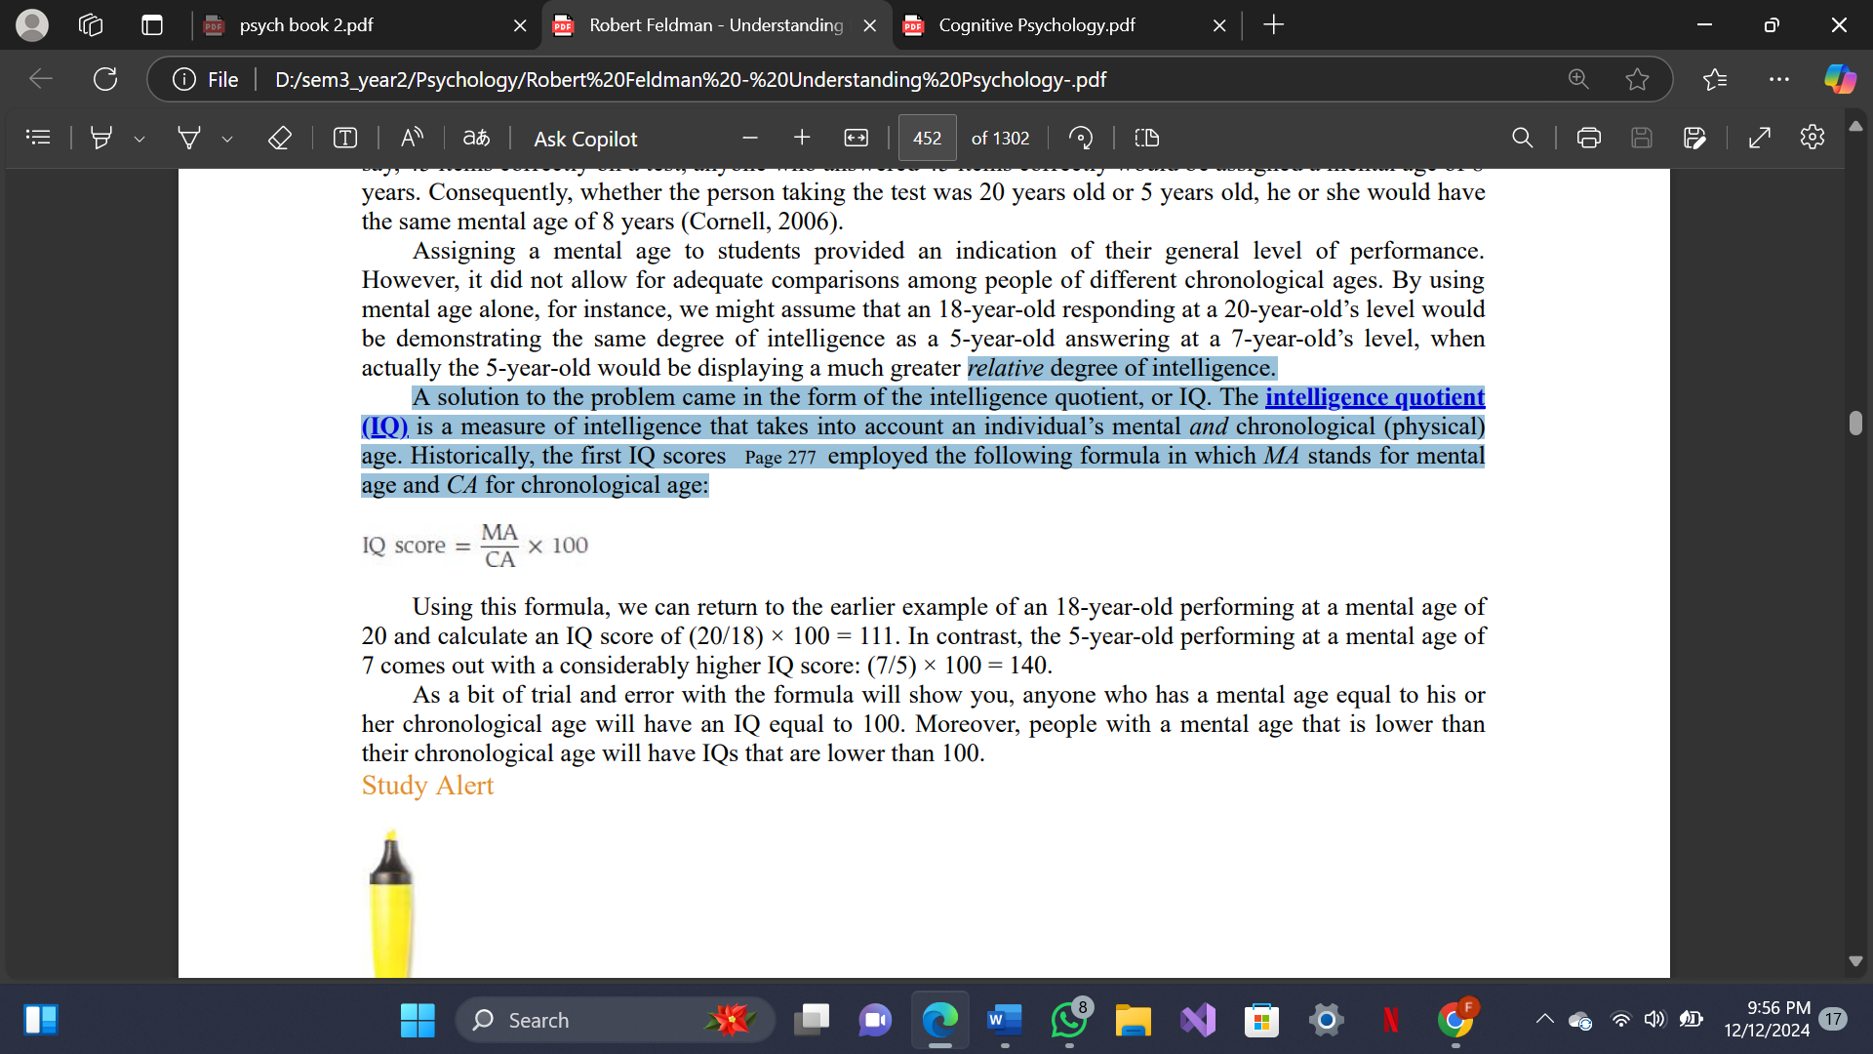

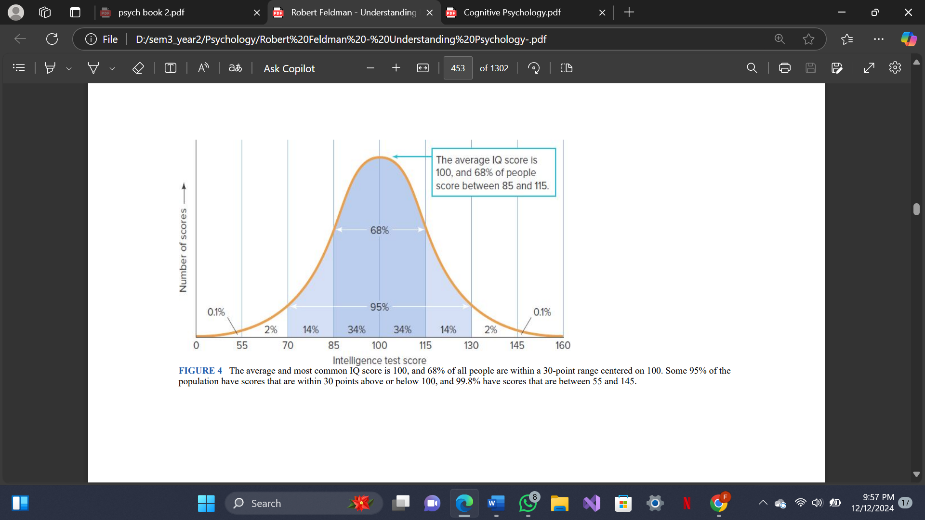

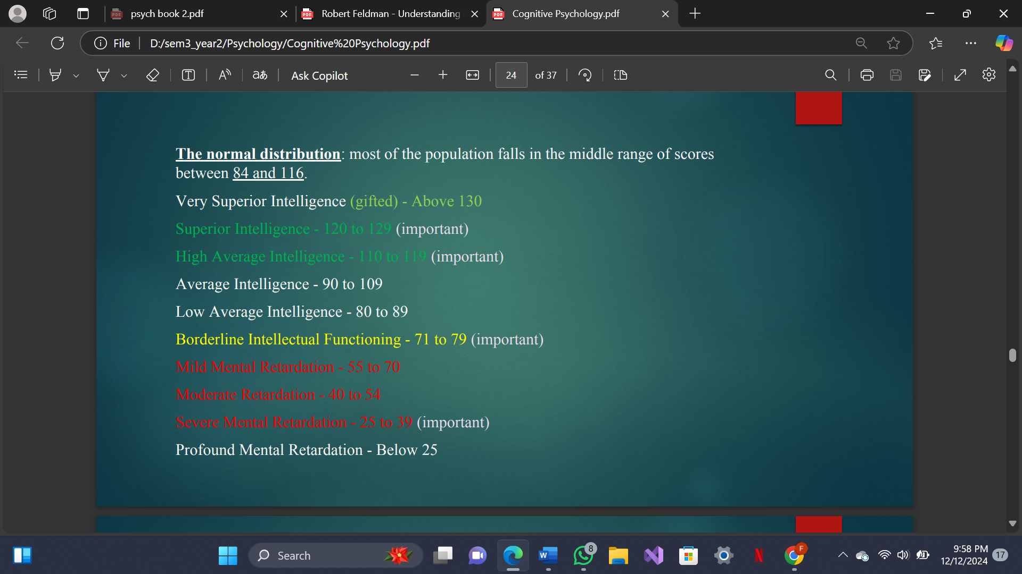

World War I and Army Personnel Selection

During World War I in 1917 a committee of American Psychological Association, under leadership of Robert M. Yerkes, prescribed the use of intelligence tests for rapid classification of army personnel. In view of this, American Army psychologists developed two tests:

1. Army Alpha - language test
2. Army Beta - non-language-performance test

Wechsler Intelligence Scales

The first Wechsler intelligence scale came in 1939. After that Wechsler scales have gone through several successive revisions for three different categories:

1. for adults (16-90 years),
2. for school-going children (6-16 years)
3. for preschoolers (2½-7 years)

**Intellectual Disabilities**

intellectual disability is a disability characterized by significant limitations in both intellectual functioning and in adaptive behavior, which covers many everyday social and practical skills, and originates before the age of 18.  
Someone with intellectual disability has limitations in two areas. These areas are:

**Intellectual functioning.** Also known as IQ, this refers to a person’s ability to learn, reason, make decisions, and solve problems.

**Adaptive behaviors.** These are skills necessary for day-to-day life, such as being able to communicate effectively, interact with others, and take care of oneself.

These problems may include seizures, mood disorders, anxiety autism, down’s syndrome, motor skills impairment, vision problems, or hearing problems.

